FERROSILICATES WITH LOW IRON CONTENT IN OXIDATION PROCESSES (TIMES NEW ROMAN 14)
1 empty line
Sidorov A.A.1, Petrov B.V.2 (Times New Roman 14)
1 empty line
- – affiliation, full name of university, company etc., counyry, city, e-mail (Times New Roman 12)
- – second organization (if applicable)
1 empty line
Text (not more than 2 pages, all margins 25 mm, Times New Roman 14). File should be called as surname and initials of the first author, e.g. SidorovAA. The abstract can be written in English or in Russian.
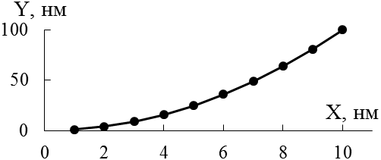
The example of figure and figure caption is presented below.
Fig. 1. The dependence of y on parameter х.

References should be given in brackets: [1].
Acknowledgement (Italic)
1 empty line
References (Times New Roman 12)
1. Dewil R., Mantzavinos D., Poulios I., Rodrigo M.A. // J. Environmental Management. 2017. V. 195. P. 93–99.

